|  |  |  |  |  |
| --- | --- | --- | --- | --- |
|  |  | |  | | --- | | When HELP Can’t Wait  NEWSLETTER | | April 2016 | |
|  |  |  |
| When help Can’t wait |  | 1st Quarter 2016 |

We have a Volunteer holding ‘Painting Classes’ at one nursing home. Some residents get to express their ‘creative side’ with watercolors and different projects while enjoying each other’s company as well.

Our newest program is holding ’Jewelry Shows’ in the homes and the residents get to select their own from a bountiful collection of costume jewelry – just like Macy’s – (well almost). It’s hard to say who has the most fun – the residents shopping or the volunteers who set up the show and get to watch the fun.

Of course our Clothes Closets continue weekly at many of the homes. We have been able to purchase some larger sizes thanks to a generous lady who donated a debit card which we used to purchase large size shirts for the men and some dresses for the ladies. We are always in need of sizes 3X and larger though, so if you know someone who needs to donate those sizes, we will be able to put them to use.

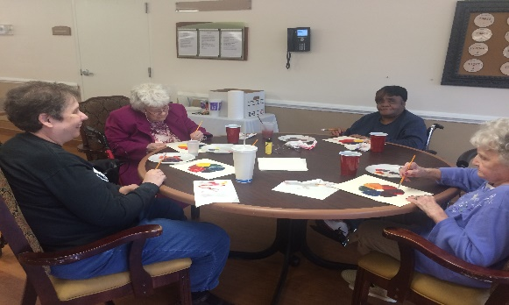

# Lots of ‘Happenings’

Painting Class

A few ladies from the nursing home enjoying themselves and painting some pictures.

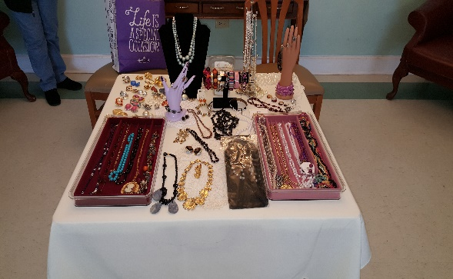

Jewelry Show

A photo from our last jewelry show. The ladies sure did have a great time looking through and trying on all the jewelry.

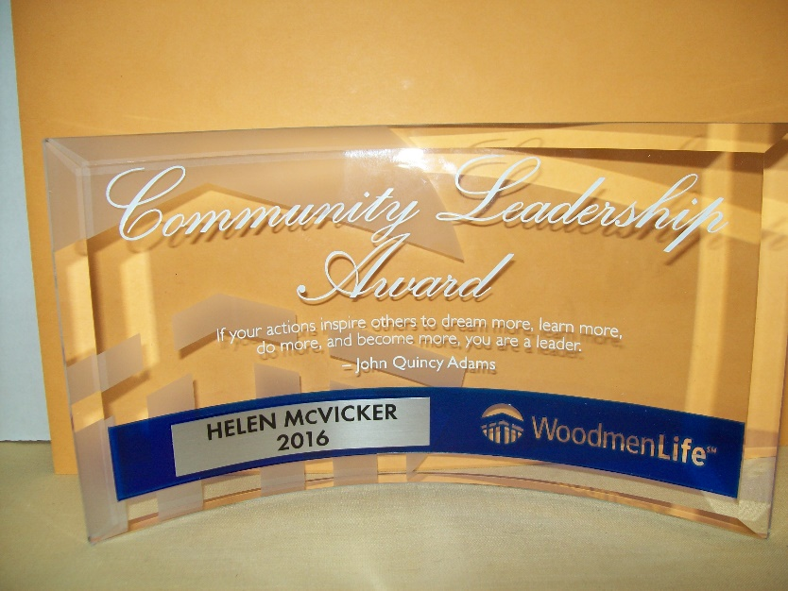This year we have been able to continue our decorating of individual resident’s rooms. Without family to help, the rooms are completely bare – our design expert, Donna has decorated rooms with colorful quilts, flower arrangements, pictures on the wall and sometimes custom designed to the resident’s interest (one Elvis inspired room is an example). This makes their days much brighter!

We were invited to speak to several Church groups and a group of retired teachers this quarter. We love these opportunities to meet new people who are interest in their community and we love to share the mission of WHCW. If you have a group that would like us to

*You’ll never know how much giving of your time and donations can mean to someone to bring a smile, brighten a day and lift their sprits. won’t you please join us in this effort?*

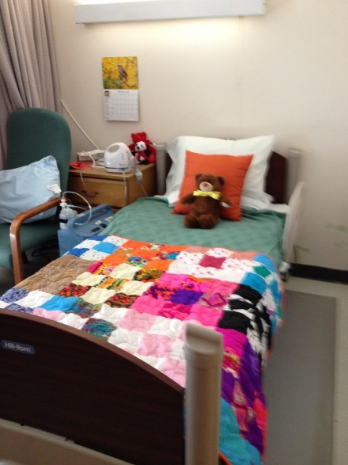

speak at one of your functions, please call our office and speak with Brandi at: 706-650-9467.

We were interviewed and enjoyed published articles in both the Augusta Chronicle and the Metro Spirit this quarter. These articles opened so many doors for us and the ladies who did the articles were simply outstanding in the job that they did.

In March, President Helen McVicker received the ‘Community Leadership Award’ from the Woodmen of the World organization. What a wonderful group of community ambassadors and we were deeply honored to accept their award.

### When HELP Can’t Wait

3843 Martinez Blvd. Ste. 101

Martinez, GA 30907

706-650-9467

[whenhelpcantwait@comcast.net](mailto:whenhelpcantwait@comcast.net)

When HELP Can’t Wait is a 501©3 organization. All donations made to our organization are tax deductible. At the current time, there are no administrative salaries in our organization. Our Board consists entirely of volunteers, including our President and Director. We are dedicated to keeping administrative costs low. Our Board is composed of local CSRA business men and women.

We were blessed to receive a grant from the Augusta Exchange Club this year. Without help of this kind, we could not sustain our missions. We also remain eternally grateful to those individual who make monthly contributions that we can rely on to help with the overhead expense of operation. One church has begun monthly donations to us and we encourage others who can to do the same. Consistency is everything in maintaining a budget and that kind of help is tremendous – no matter the size of the monthly contribution – they add up.

We continue to serve Nursing Home residents across and beyond the CSRA to the best of our ability, furnishing them every comfort and convenience items that we can. Churches like Lewisville United Methodist have ‘refurbished’ patios and a group from First Baptist furnished Valentine gifts – so help from the community makes WHCW a ‘community affair’ - as they say ‘It takes a village’ and for many of the nursing homes we serve, that’s such a true statement and we sincerely appreciate every assist that we receive from the community.

Ways that you can help:

**Financial gifts may be made in honor of or to remember a special loved one. A notice will be sent to the honoree or to the family of those being remembered.**

* **Tax Laws encourage charitable giving and these gifts may significantly reduce income taxes for some donors.**
* **Planned gifts or bequests made through estate planning or trust as well as allowances for IRA owners who must take RMDs are some of the best tax advantages of giving.**
* **Our goal is to establish an Endowment Fund to insure the continuance of When HELP Can’t Wait into the future.**

You’ll never know how much giving of your time and donations can mean to someone to bring a smile, brighten a day and lift their spirits. Won’



Supplying current needs for the comfort

And convenience of Nursing Home

Residents in the CSRA

**Find us online at:**

**www.whenhelpcantwait.com**

